**PROJECT REPORT FORMAT**

1. **INTRODUCTION**
2. Project Overview
3. Purpose
4. **LITERATURE SURVEY**
5. Existing problem
6. References
7. Problem Statement Definition
8. **IDEATION & PROPOSED SOLUTION**
9. Empathy Map Canvas
10. Ideation & Brainstorming
11. Proposed Solution
12. Problem Solution fit
13. **REQUIREMENT ANALYSIS**
14. Functional requirement
15. Non-Functional requirements
16. **PROJECT DESIGN**
17. Data Flow Diagrams
18. Solution & Technical Architecture
19. User Stories
20. **PROJECT PLANNING & SCHEDULING**
21. Sprint Planning
22. Sprint Estimation and Delivery Schedule
23. **CODING & SOLUTIONING (Explain the features added in the project along with code)**
24. SendGrid
25. Database Schema

**8.TESTING**

**9.RESULTS**

**10.ADVANTAGES & DISADVANTAGES**

**11.CONCLUSION**

**12.FUTURE SCOPE**

**13.APPENDIX**

1. **INTRODUCTION**
2. ***Project Overview: -***

Plasma is typically given to patients with severe liver disease or multiple clotting factor deficiencies, as well as those who have had trauma, burns, or shock. As a result, the patient's blood volume increases, which aids in blood coagulation and helps to prevent shock. The number of persons infected with Covid-19 has grown, as has the need for plasma from recovered patients. Antibodies already present in our body can help someone overcome an illness.

Plasma donation saves lives, and communication between donors and blood/plasma facilities is critical. Smart applications are increasingly seen as an important communication tool, and if they are designed with the needs and preferences of the users in mind, plasma donation might make the greatest use of them.

1. ***Purpose: -***

In our opinion, we intend to develop a user-friendly application for people who require plasma or who wish to donate plasma to anyone in need.

Nevertheless, areas of concern like as privacy and secrecy should be considered during design and development. Age was discovered to be a factor that may affect donors' proclivity to utilize applications. If somebody need a Plasma Donor, they can use this system.

This system comprises of Admin and User where both can request for a Plasma.

* Both parties can Accept or Reject the request.
* The person who wishes to donate plasma must first register in our application, providing necessary information such as name, age, blood group, phone number, and location, among other things.
* Patients who need plasma can also fill the form to request the plasma. Patients can directly call the donor by taking his/her contact number from the application.
* User can also search based on location they are living
* Just a single search allows anyone to reach maximum number of plasma donors in minimum possible time .

1. **LITERATURE SURVEY**
2. ***Existing Problem:***

For most existing plasma donor applications, the system is closed for general plasma donation and is primarily focused on COVID-19 patients for plasma donation; the android mobile user will be unable to insert or view details if the server goes down, which is a disadvantage of single point of failure. The majority of user information is unconfirmed, making it tough to hunt down bogus users. The application's user interface is not user pleasant, and in order to engage with it, the user must have a smartphone running the Android operating system and an active internet connection.

1. ***References: -***

|  |  |  |  |  |  |
| --- | --- | --- | --- | --- | --- |
| **YEA**  **R** | **TITLE** | **AUTHOR(**  **s)** | **TECHNIQ**  **UE(s)** | **PROS** | **CONS** |
| 2022 | Instant Plasma Donor Recipient connector web application n | Kalpana Devi Guntoju, Tejaswini Jalli, Sreeja Uppala, Sanjay Mallisetti | Web Technol ogies, API,  Databas e | The Donor needs to upload their recovered COVID-19  Certificate and it required to verified by the blood bank. It is a user- friendly application.  It will help people to find  plasma easily. | This is system is closed for general plasma donation and mainly focused on COVID-19  patients for plasma donation |
| 2021 | BDoor App-Blood Donation Applicatio n using Android Studio | S  Periyana yagi, A Manikan dan,M Muthukris hnan,and M  Ramakris hnan | Android, FlutterUI, Dart, Firebase, Decision tree algorithm | The Donor details are verified before they allow to donate and have to authorised by institution.  The Verification and  validation are done in Email  base. | The android mobile user will not be able to insert or view details if the server goes down. Thus, there is disadvantage  of single point failure. |

|  |  |  |  |  |  |
| --- | --- | --- | --- | --- | --- |
| 2020 | Lifesaver E-Blood Donation App Using Cloud | Rishab Chakrab arti, Asha Darade, Neha Jadhav, Prof. S. M.  Chitalka r | E-health, GPS,  Blood bank database, Cloud Computin g | Reduction in the errors ofblood bank using most eligible donor method.  Direct Communicatio n Between donor and the person in need of blood During the  Emergency situation. | The user given details are maintained unverified. |
| 2020 | Developin g a plasma donor applicatio n using Function- as-a- service in AWS | Aishwa rya R Gowri | Serverless  , aws, plasma theory, covid19, dynamoD B, cloud | The efficient way of findingplasma donor for the infected people. Aws lambda function is used and to deploy the application AWS EC2 service is  used. | The user interface can be better than now. |
| 2019 | D’WORL  D: Blood Donation App Using Android | A.  Meiyappan  ,  K. Loga Vignesh, R. Prasanna, T. Sakthivel | Android, Global Positioning g System (GPS),  Mobile Computin g | When the giver gives the blood, it will naturally evacuate the contributor detail for next three months.It additionally confirms with the Department of Health and Welfare to guarantee the  benefactor medical case history. | The user must have an device with android operating system with an active internet connection to interact with this application. |
| 2018 | Automated blood bank system using Raspberry PI | Ashlesha C.  Adsul,  V. K. Bhosale,  R. M. Autee | Raspber ry Pi, Embedd ed Blood Bank, GSM,  Android | When there is urgent need for blood then If this model is adopted the caller is immediately connected to the  donor | Tackling the fakeusers. |

1. ***Problem Statement Definition: -***

Plasma donation saves lives, and communication between blood/plasma centres and donors is critical. Smart applications are currently seen as a significant communication tool, and they might be most effective in plasma donation if they are tailored to the needs and interests of the users. We intend to provide a user-friendly application for users who require plasma or wish to donate plasma to anyone in need. However, issues like as privacy and confidentiality should be considered throughout design and development. Age was discovered as a factor that may reduce the chance of app utilisation among donors. The donation centre personnel stressed the app's instructional aspects and the necessity of the app providing statistics and sending notifications and reminders to donors.

1. **IDEATION & PROPOSED SOLUTION**

***3.1. Empathy Map Canvas:-***

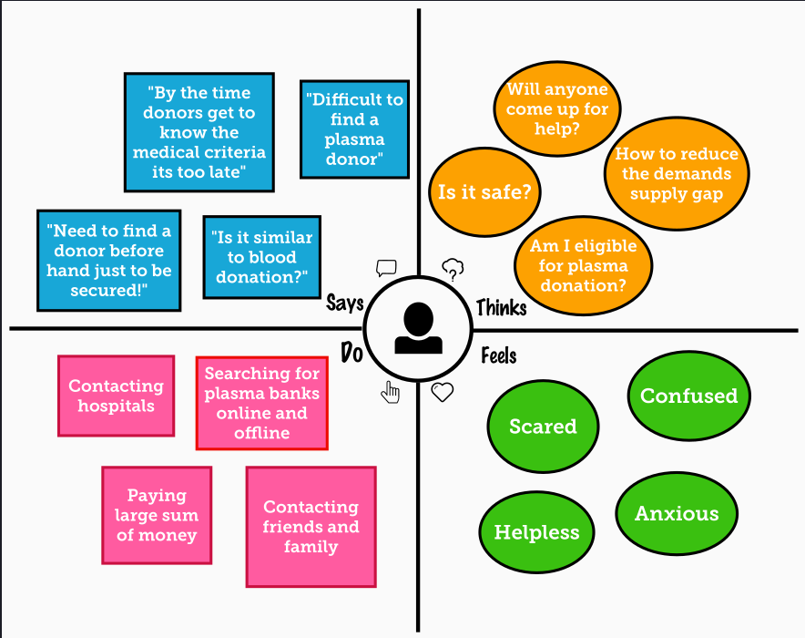

1. ***Ideation & Brainstroming:-***

Plasma is utilised to treat major medical conditions. This is why blood drives are held to encourage individuals to give blood and plasma. Plasma is used to treat several irreversible illnesses and is one of the most established plasma therapy options. During the Coronavirus emergency, the need for plasma increased dramatically because no immunisation was discovered to treat the contaminated patients; with plasma therapy, the recovery rates were high, but the donor count was very low, and in such situations, it was critical to obtain information about the plasma donors. Saving the contributor data and informing the ongoing givers would be beneficial because it would save time and help the clients find important information about the donors.

1. ***Proposed Solution:-***

This suggested approach uses an internet application to connect donors and patients. Users can use this application to submit a request for plasma donation or needs.

The basic solution is to establish a centralised system for tracking upcoming and past Plasma Donation Events. The suggested solution is as follows:

Application contains two roles:

* If the user wants to donate or receive they have to register with their personal details.
* After successful registration of user.
* A successful registration email is send to the user.
* After successful registration user will be directed to home page.
* They will be asked to press whether they will be donor or receiver.
* If the user is donor then he/she will fill the donation interest form which includes their Name, blood group details, location, last time donated date , phone number, email id.
* After filling the donation form he/she will redirected to page in which he/she can download the ecertificate.
* If the user is receiver then he/she can see the list of donors available and they can raise their request and contact donor directly.

Admin:

* Admin can login using their credentials.
* Admin can edit the request.
* Admin can delete the request.
* Admin can add volunteers.

1. ***Problem Solution Fit:-***

***Uniqueness:-***

Users can easily grasp a User Interface. We may utilise the programme whenever and wherever we choose. If the user requires plasma immediately for their treatment but it is not available in nearby hospitals, they can use this application to raise a request and directly contact the donor, requesting that they donate the plasma. Hospitals can also solicit donors for donations. If someone wants to donate blood or plasma but doesn't know how, they can use this application, which is simple to use and will save the lives of many people. Many of them now have mobile phones on which they can install this application and use it to save people's lives.

***Social Impact / Customer Satisfaction:-***

We live in a modern society where everything is available online. Despite the fact that there are several applications, there is no official application for plasma donation. Many of them would like to donate blood and plasma, but many are uninformed of the process. This application allows anyone who wish to give plasma to do so. Numerous people come forward to give plasma in many areas, however it is not accessible at the correct moment for usage. There are occasions when a specific type of plasma is in limited supply. We also require the ability to swiftly obtain patient information prior to plasma transfusion. To address this issue, software programmes with Cloud computing and Internet of Things tools are used, which provide capabilities such as information retrieval and continuous data tracking with analytics. This programme prevents incorrect information from spreading. A single platform for preserving authentic information and increasing the confidence of participants in this activity. It boosts the number of contributors.

***Business Model (Revenue Model):-***

This application is available to everyone. It is completely free. Due to the difficulty in locating providers who match a certain blood group, this application allows customers to enrol persons who want to give plasma and save their data in a data collection. The need for plasma is increasing. This programme is accessible to anybody with minimal computer skills. This may be utilised at any time and in any place. Working with the government, we can develop an application to assist individuals in need of plasma.

***Scalability of the Solution :-***

This programme allows users to discover plasma donors while sitting at home, rather than searching for donors all over the place. When there is an emergency, plasma requests that it be sent to everyone. When the donor is ready to contribute, the recipient is alerted.

The recipient can contact the donor. With this software, donors may determine their eligibility to donate, making it simpler to find a compatible donor at the appropriate moment.

1. **REQUIREMENT ANALYSIS**
2. ***Functional Requirements:-***

Following are the functional requirements of the proposed solution.

|  |  |  |
| --- | --- | --- |
| **FR**  **No.** | **Functional**  **Requirement (Epic)** | **Sub Requirement (Story / Sub- Task)** |
| FR-1 | User Registration | Registration through Website |
| FR-2 | User Confirmation | Confirmation via Email |
| FR-3 | User Login | Login using Registered email Id |
| FR-4 | Sent Request | If plasma is required, the receiver will contact  the donor |
| FR-5 | Contact Donor | Contact the donor directly if a phone number  is given |
| FR-6 | View donation camps | View the list of donation camps happening  nearby |

1. ***Non- Functional Requirements:-***

Following are the non-functional requirements of the proposed solution.

|  |  |  |
| --- | --- | --- |
| **FR**  **No.** | **Non-Functional Requirement** | **Description** |
| NFR- 1 | **Usability** | The user interface of the plasma donorsystem must  be well-designed and welcoming. |

|  |  |  |
| --- | --- | --- |
| NFR- 2 | **Security** | Data storage is required by security systems, just like it is by many other applications. Databases are able to keep all the donor information that is viewed by applications. It must be  secured with email Id and password. |
| NFR- 3 | **Reliability** | The system has the ability to work all the times without failures apart from network failure. A donor can have the faith on the system. The authorities will keeps  the privacy of all donors in a proper manner |
| NFR- 4 | **Performance** | The Plasma donor System must perform well in different scenarios.  The system is interactive and delays involved are less. |
| NFR- 5 | **Availability** | The system, including the  onlinecomponents, should be available 24/7. |
| NFR- 6 | **Scalability** | The system offers the proper resources forissue solutions and is designed to protect sensitive information during all phases of operation. |

1. **PROJECT DESIGN**
2. ***Data Flow Diagrams: -***

**Data Flow Diagrams:**

A Data Flow Diagram (DFD) is a traditional visual representation of the information flows within a system. A neat and clear DFDcan depict the right amount of the system requirement graphically. It shows how data enters and leaves the system, what changes the information, and where data is stored.

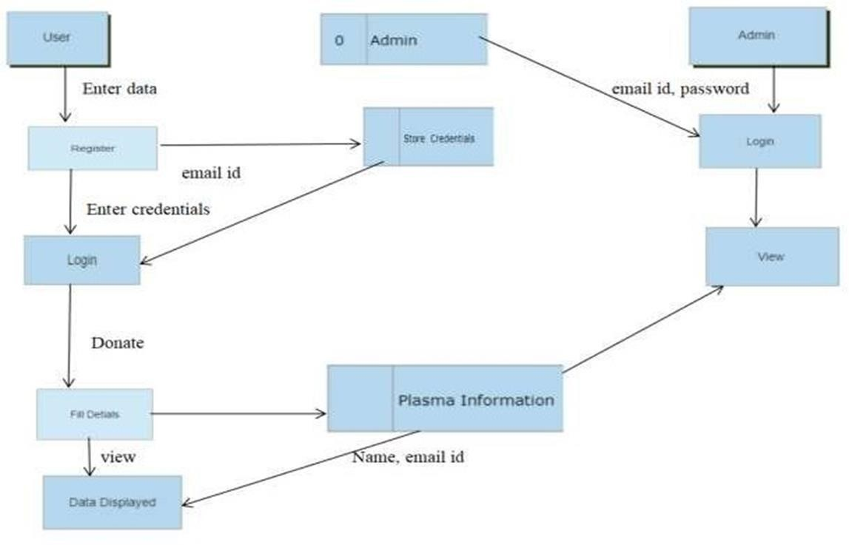

1. ***Solution & Technical Architecture: -***

Solution Architecture: -

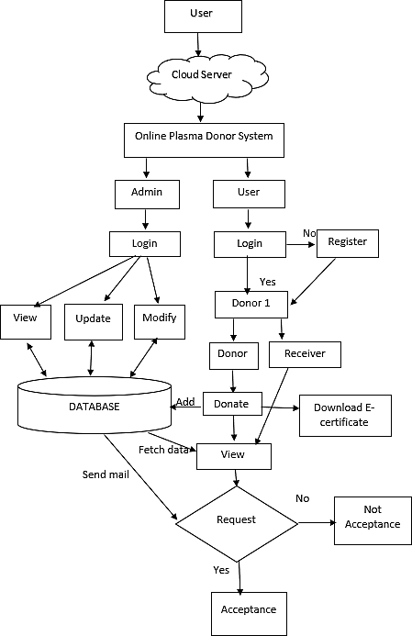

Technical Architecture:-

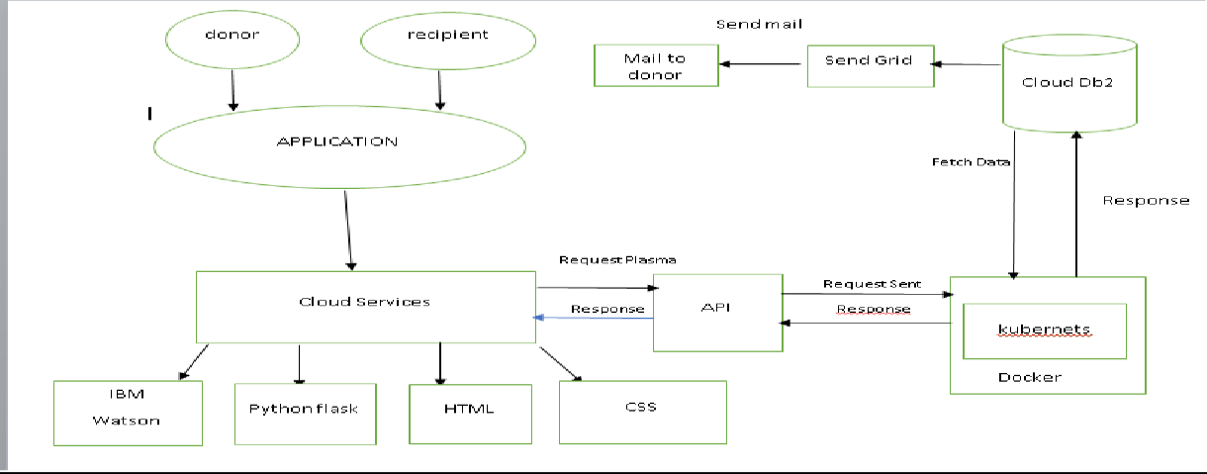

|  |  |  |  |  |  |  |
| --- | --- | --- | --- | --- | --- | --- |
| **User Type** | **Functional Requir ement (Epic)** | **User Story Num**  **ber** | **User Story / Task** | **Acceptance criteria** | **Priorit y** | **Release** |
| web | Registratio n | USN- 1 | As a user, I can register for the  application by entering my email,password. | I can access my account dashboar  d | High | Sprint-1 |
| web |  | USN- 2 | As a user, I will receive  confirmationemail once I have registered  for the application | I can receive successful message | High | Sprint-2 |
| web | Login | USN- 3 | As a user, I can log into the  application by entering email &password | I can access into myProfile and view  my dashboard | High | Sprint-3 |
| web | Dashboard | USN- 4 | As a user, I can login using my credentials and it will direct it to my dashboard | I can view and access what are the features are provided  in dashboard | High | Sprint-4 |
| web |  | USN- 5 | As a user, I can login using my credentials and it will direct itto my  dashboard | I can view and access what are the features are provided in dashboard | High | Sprint -4 |

1. **PROJECT PLANNING AND SCHEDULING**
2. ***Sprint Planning***

Sprints are the foundation of every successful Agile development team. And the better you prepare for a sprint, the more likely you are to meet your objectives. Spring planning may assist to redirect attention, reduce surprises, and (ideally) ensure that better code is deployed. The sprint is the major event in agile methodology; it is the stage at which ideas become innovation and good products are born. Agile sprints, on the other hand, may be incredibly successful and collaborative. At the same time, they can be chaotic and inefficient if sufficient planning and guidance are not provided. As a result, creating a sprint plan is one of the most crucial things you can do to assure the success of your efforts.

We categorized the sprint as 4 phases for creating the application

* Sprint 1 is about creating the login page and the register page.
* Sprint 2 is about sending the confirmation mail to the users during registration.
* Sprint 3 is about as a user, can log into application by entering email and password.
* Sprint 4 is about as user, can register and make request for plasma donation via portal.

The Deliverable shall include the architectural diagram as below and the information as per the table1 & table 2

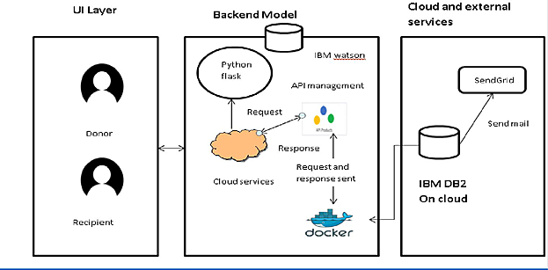

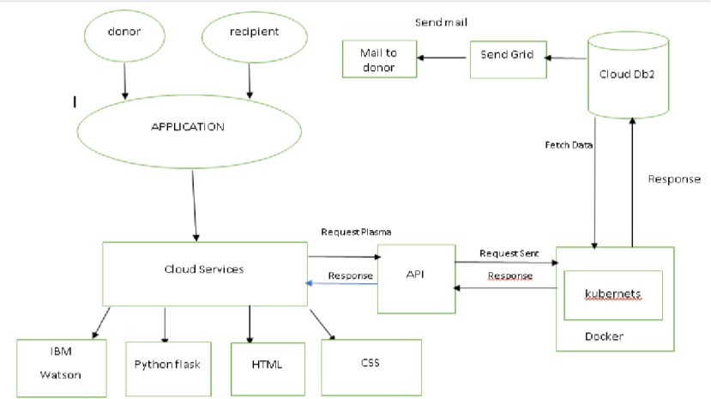

Guidelines:

1. Include all the processes (As an application logic / Technology Block)
2. Provide infrastructural demarcation (Local / Cloud)
3. Indicate external interfaces (third party API’s etc.)
4. Indicate Data Storage components / services
5. Indicate interface to machine learning models (if applicable)

**Table-1 : Components & Technologies:**

|  |  |  |  |
| --- | --- | --- | --- |
| **S.N**  **o** | **Component** | **Description** | **Technology** |
| 1. | User Interface | The user register and login. | HTML, CSS, Python Flask |
| See the UI. |
| 2. | Chatbot | Clarify user queries. | IBM Watson service |
| 3. | Confirmation Email | Sending the confirmation email to users | SendGrid |
| they have registered successfully. |

|  |  |  |  |
| --- | --- | --- | --- |
| 4. | Cloud Database | Cloud database to store plasma | IBM DB2 |
| information and View Plasma information. |
| 5. | File Storage | File storage requirements | IBM Block Storage |
| 6. | Infrastructure (Server / Cloud) | To deploy the application on Local System | Kubernetes |
| 7 | Docker image | To store the docker image in cloud | Docker hub |

|  |  |  |  |
| --- | --- | --- | --- |
| **S.N**  **o** | **Characteristics** | **Description** | **Technology** |
| 1. | Open-Source Frameworks | Python Flask frameworks is used. | Python Flask |
| 2. | Security Implementations | Mandatory Control(MAC) and kubernetes is | SHA-256, Encryptions, IAM |
| used. | Controls, OWASP etc. |
| 3. | Scalable Architecture | 3-Tier Architecture is used. | Web server-HTML,CSS |
| Application Server- Python |
| Flask Database Server- IBM |
| DB2 |
| 4. | Availability | Using Load Balancer to distribute network | IBM Load Balancer |
| traffic across Servers. |
| 5. | Performance | User Friendly UI. | IBM Content Delivery Network |
| Request and Response is faster. |

1. ***Sprint Estimation and Delivery Schedule:***

A sprint estimation shows how much effort a series of tasks require. It’s based on assumptions, requirements, and dependencies of a project.

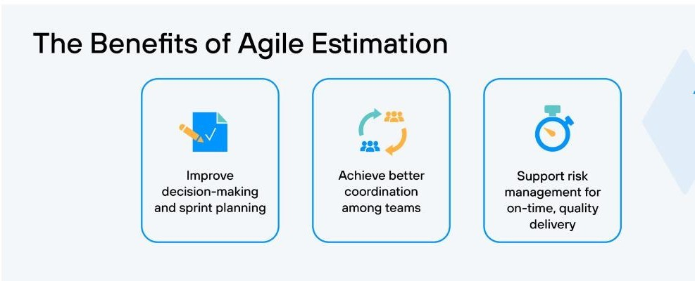

Use the below template to create product backlog and sprint schedule

|  |  |  |  |  |  |  |
| --- | --- | --- | --- | --- | --- | --- |
| **Sprint** | **Functional** | **User Story** | **User Story / Task** | **Story Points** | **Priority** | **Team** |
| **Requirement (Epic)** | **Number** | **Members** |
| Sprint-1 | Registration | USN-1 | As a user, I can register for the application by | 2 | High | SRIRAM |
| entering my email, password, and confirming | SANJAY |
| my password. |  |
| Sprint-1 | Registration | USN-2 | As a user, I will receive confirmation email once | 1 | High | VASANTH |
| I have registered for the application | THAVAMUTHUBASKARAN |

|  |  |  |  |  |  |  |
| --- | --- | --- | --- | --- | --- | --- |
| Sprint-2 | Database | USN-3 | Join the application to IBM db-2 | 2 | Low | SRIRAM |
| SANJAY |
| Sprint-1 | Login | USN-4 | As a user, I can log into the application by | 1 | High | VASANTH |
| entering email & password | THAVAMUTHUBASKARAN |
| Sprint-2 | Dashboard | USN-4 | As a user, I can register and make request for | 2 | High | SRIRAM  SANJAY |
| plasma donation. |  |

**Project Tracker, Velocity & Burndown Chart**

|  |  |  |  |  |  |  |
| --- | --- | --- | --- | --- | --- | --- |
| **Sprint** | **Total Story** | **Durat ion** | **Sprint Start Date** | **Sprint End Date** | **Story Points** | **Sprint Release Date** |
| **Points** | **(Planned**  **)** | **Completed (as on** | **(Actual)** |
|  |  | **Planned End Date)** |  |
| Sprint-1 | 20 | 6  Days | 24 Oct  2022 | Oct 2022 | 20 | 29 Oct  2022 |
| Sprint-2 | 20 | 6  Days | 31 Oct  2022 | Nov 2022 | 20 | 05 Nov  2022 |
| Sprint-3 | 20 | 6  Days | 7 Nov 2022 | Nov 2022 | 20 | 12 Nov  2022 |
| Sprint-4 | 20 | 6  Days | 14 Nov  2022 | Nov 2022 | 20 | 19 Nov  2022 |

**Velocity:**

Imagine we have a 10-day sprint duration, and the velocity of the team is 20 (points per sprint). Let’s calculate the team’s average velocity (AV) per iteration unit (story points per day)

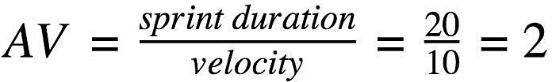

1. **CODING & SOLUTIONING**
2. ***SendGrid***

SendGrid is a cloud-based SMTP solution that enables you to send email without the need for email servers. SendGrid handles all technical aspects, from infrastructure scalability to ISP outreach and reputation monitoring to whitelist services and real-time analytics.

SendGrid offers two methods for sending email: via our SMTP relay or via our Web API. SendGrid offers client libraries in a variety of languages. This is the recommended method of integrating with SendGrid. If you prefer to use SendGrid without a client library, the Web API is recommended in most circumstances since it is quicker, has certain encoding benefits, and is generally easier to use. SMTP has numerous functions by default, but it is more difficult to set up.

**Web API**

* The Web API has some advantages over SMTP:
* If your ISP blocks all outbound mail ports and your only option is HTTP.
* If there is high latency between your site and ours, the Web API might be quicker since it does not require as many messages between the client and server.
* If you do not control the application environment and cannot install and configure an SMTP library.
* If you build a library to send email, developing against a web API provides quicker development.

**SMTP Relay**

* If you are integrating SendGrid with an existing application, setting up the application to use our SMTP relay is easiest, as it only requires modifying SMTP configuration.
* Change your SMTP username and password to your SendGrid credentials.
* Set the server host name to smtp.sendgrid.net
* Use ports 25 or 587 for plain/TLS connections and port 465 for SSL connections.

***Code:***

*import os*

*from dotenv import load_dotenv load_dotenv()*

*from sendgrid import SendGridAPIClient from sendgrid.helpers.mail import \**

*def mailtest_registration(to_email):*

*sg = sendgrid.SendGridAPIClient(api_key= api_key )*

*from_email = Email("19cs157@kpriet.ac.in")*

*subject = "Registration Successfull!"*

*content = Content("text/plain", "You have successfully registered as user. Please Login using your Username and Password to donate/request for Plasma.")*

*print('mailing')*

*mail = Mail(from_email, to_email, subject, content)*

*response = sg.client.mail.send.post(request_body=mail.get())*

*print(response.status_code)*

*print(response.body)*

*print(response.headers)*

1. ***Database Schema***

CREATE TABLE LOGIN (

username varchar(255),

usermail varchar(255),

usercontact varchar(255),

password varchar(255)

);

CREATE TABLE DONOR2 (

name varchar(255),

mobile varchar(255),

email varchar(255),

age int,

gender varchar(10),

blood varchar(255),

area varchar(255),

city varchar(255),

district varchar(255)

);

CREATE TABLE REQUEST2 (

drmail varchar(255),

hospitalname varchar(255),

recname varchar(255),

recmobile int,

recmail varchar(255),

recage int,

recgender varchar(10),

recbloodgroup varchar(255),

recarea varchar(255),

reccity varchar(255),

recdistrict varchar(255)

);

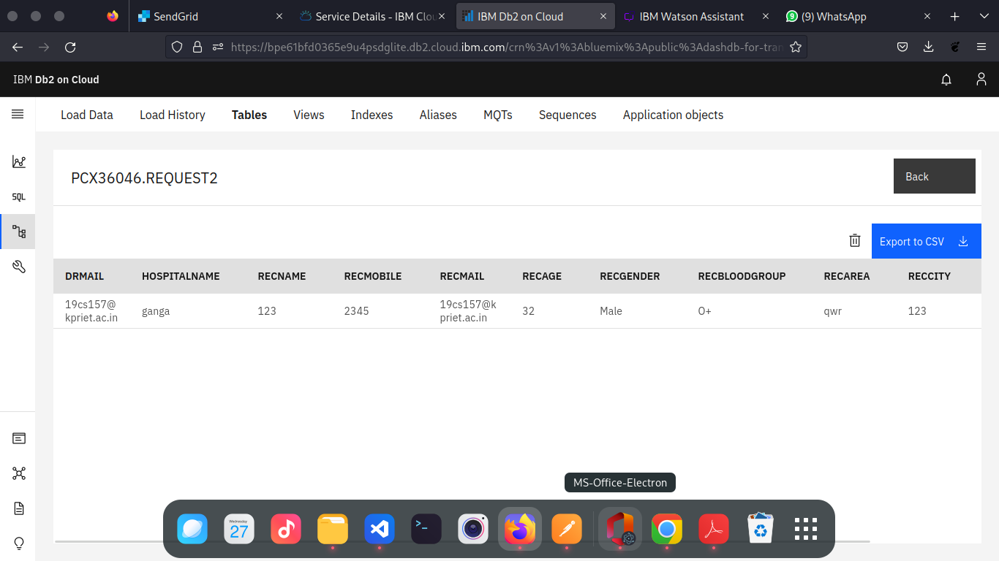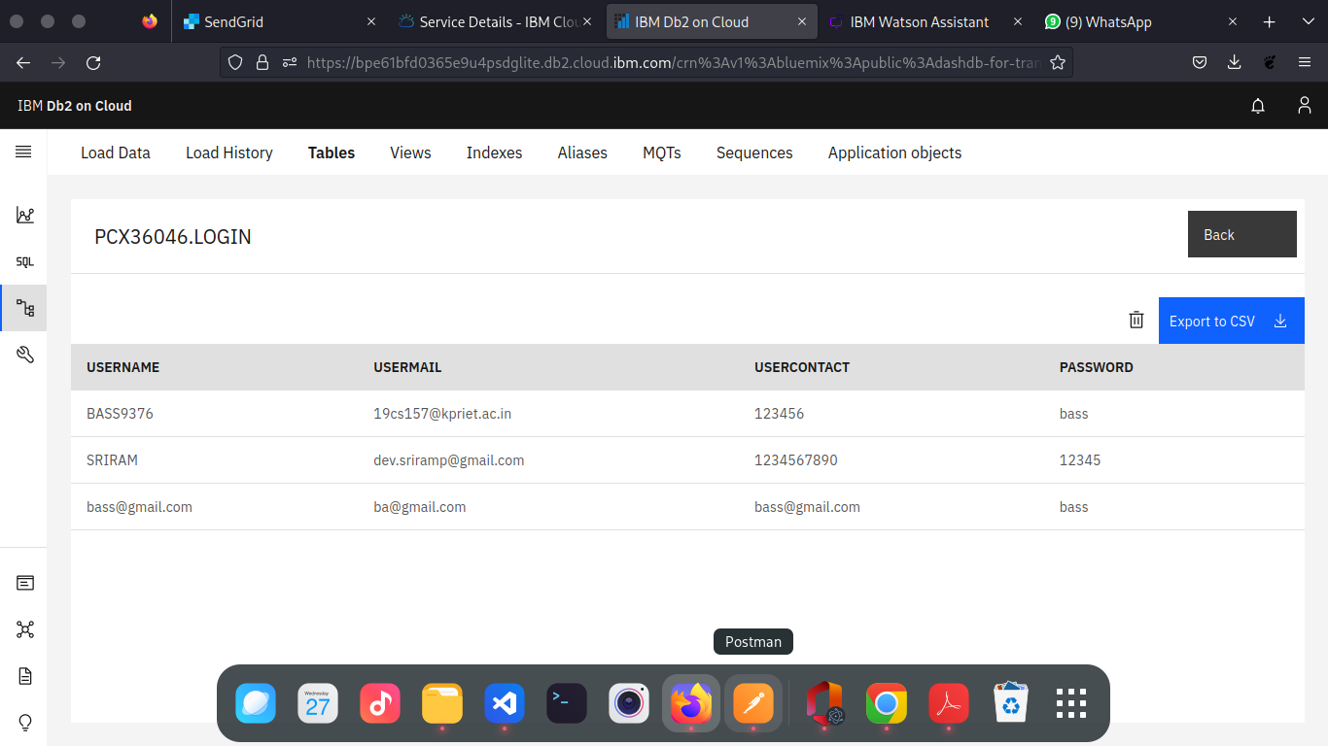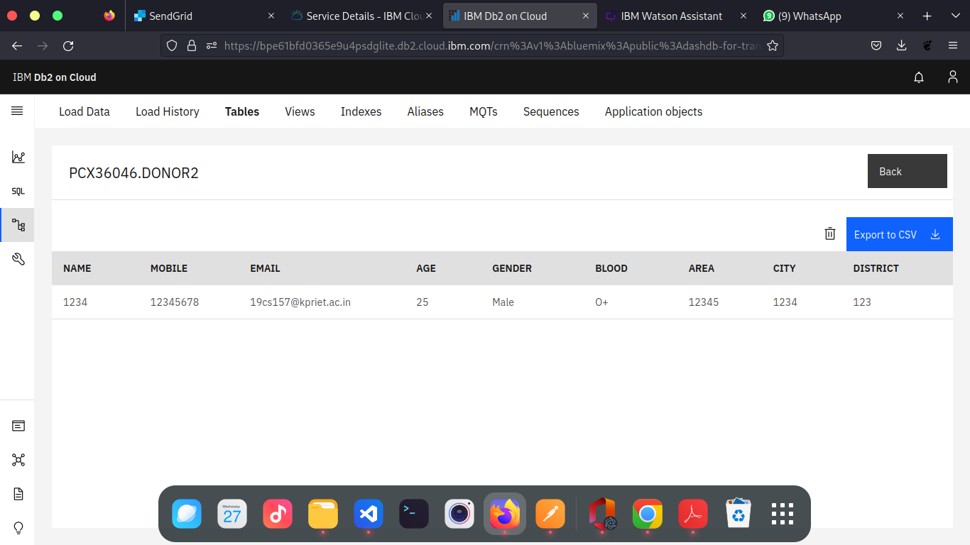

**8.TESTING**

|  |  |  |  |  |  |  |  |
| --- | --- | --- | --- | --- | --- | --- | --- |
| **TEST ID** | **FEATURE / MODEL** | **DESCRIPTION OF TASKS** | **CONDITION** | **EXPECTED RESULTS** | **RESULT** | **DEFECT / COMMENTS / ADDITIONS** | **BUGID** |
| 1 | Regester Page | A signup page (also known as a registration page) enables users and organizations to independently register and gain access to your system. It is common to have multiple signup pages depending on the types of people and organizations you want to register. | New User Regester | Enter their data's to the user Table | Pass | Everything is working Fine | Nil |
| Already Registered User | Ask the user to log in | Pass | Nil |
| 2 | Login Page | The login page allows a user to gain access to an application by entering their username and password or by authenticating using a social media login. | If the entered email id and password match with the datat in the database. | Move to the dashboard | Pass | Working good | Nil |
| If the entered email id and password not match with any of the data in the database. | show the error message | Pass | **Comments:** After the error message move the user to the login page. | Nil |
| 3 | Dashboard Page | In this dash board we can able to see the total two options one is for the requestor page and another one is donor. | If the user is loged in. | Shows the data's that are related to that logged in user. | Pass | Working fine | Nil |
| 4 | Donor Page | In Donor page one can able to donate their plasma. | User can able to donate | User is able to donate plasma | Pass | **Comments:** After the donate show the user that the update alert message not just the normal message at the top. | Nil |
| Click Logout Button | Clear the flask session variables and move to the login page | Pass |  | Nil |
| 5 | Requestor page | In Requestor page one can able to request for plasma from the donor lise | On filling the form user can receive plasma | The user can raise a request | Pass | **Comments:** Display alert message after the addition of details. | Nil |
| 6 | SendGrid | By using the SendGrid we can able to send the mail to the user. About the Expense is over the budget. |  | Mail to the user's registered email | Pass |  | Nill |

1. **Acceptance Testing:**

**Purpose of Document**

The purpose of this document is to briefly explain the test coverage and open issues of the Plasma Donor application project at the time of the release to User Acceptance Testing (UAT).

**Defect Analysis**

This report shows the number of resolved or closed bugs at each severity level, and how they were resolved.

|  |  |  |  |  |  |
| --- | --- | --- | --- | --- | --- |
| **Resolution** | **Severity 1** | **Severity 2** | **Severity 3** | **Severity 4** | **Subtotal** |
| By Design | 3 | 4 | 2 | 3 | 20 |
| Duplicate | 1 | 0 | 3 | 0 | 4 |
| External | 2 | 3 | 0 | 1 | 6 |
| Fixed | 12 | 2 | 4 | 20 | 37 |
| Not Reproduced | 0 | 0 | 1 | 0 | 1 |
| Skipped | 0 | 0 | 4 | 2 | 2 |
| Won't Fix | 0 | 5 | 2 | 1 | 8 |
| Totals | 24 | 14 | 16 | 27 | 77 |

**Test Case Analysis**

This report shows the number of test cases that have passed, failed, and untested.

|  |  |  |  |  |
| --- | --- | --- | --- | --- |
| **Section** | **Total Cases** | **Not Tested** | **Fail** | **Pass** |
| Print Engine | 5 | 0 | 0 | 5 |
| Client Application | 30 | 0 | 0 | 30 |
| Security | 3 | 0 | 0 | 3 |
| Outsource Shipping | 3 | 0 | 0 | 3 |
| Exception Reporting | 5 | 0 | 0 | 5 |
| Final Report Output | 3 | 0 | 0 | 3 |
| Version Control | 3 | 0 | 0 | 3 |

**9.RESULT**

1. ***Authentication Module***

* Sign Up

New user or donor can create an account to use in the blood/plasma donor application and create a password for account verification and create an identity.

* Sign In

Donor Sign In to the account for viewing or editing location details and any other personal information.

* Account Verification

If donor changes their password or if they forget the password then we have to verify their account using mail verification.

1. ***Service Provider Module***

* Add New Donor

User can be able to register to add donor details.

* List All Donor

User can be able to view all Donor who all use our Plasma Donor Application.

* Edit Customer Plan Details

User can be able to edit the existing Donor details as the Donor

wish.

1. ***Screen Layouts***

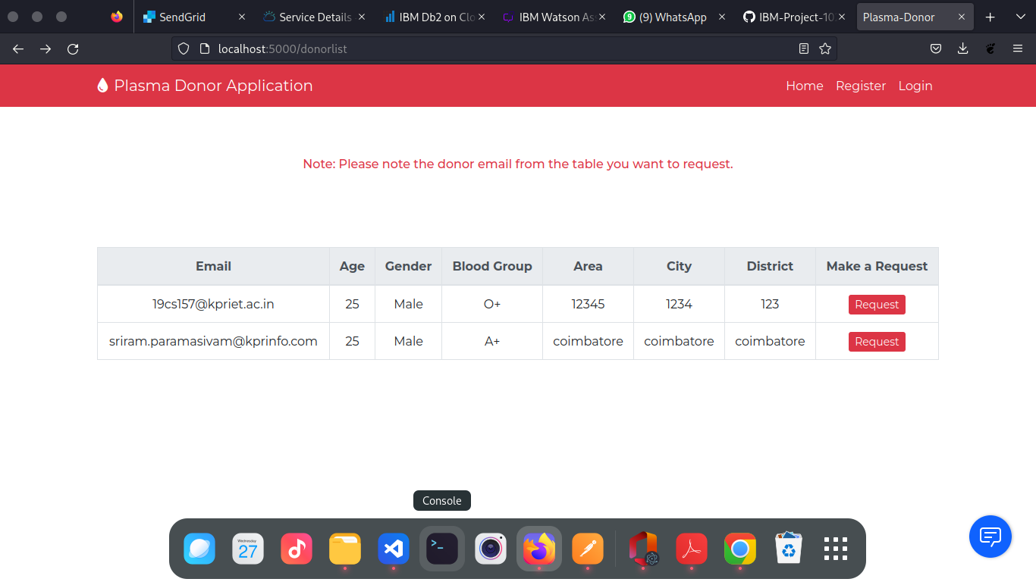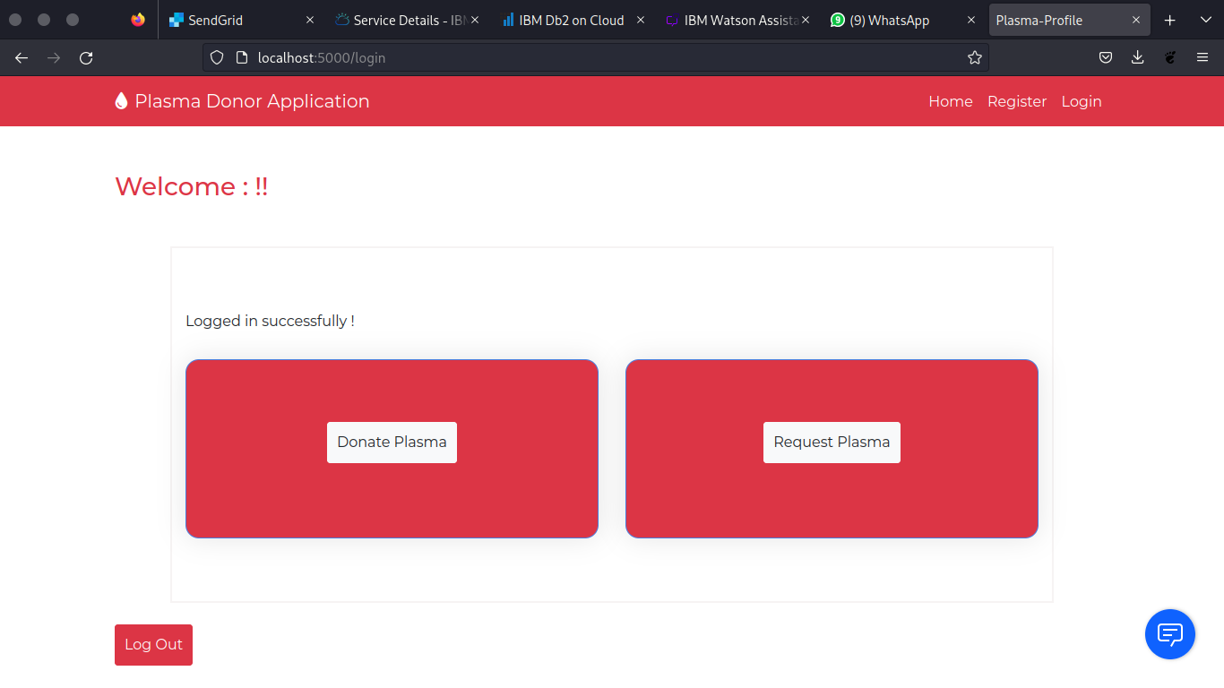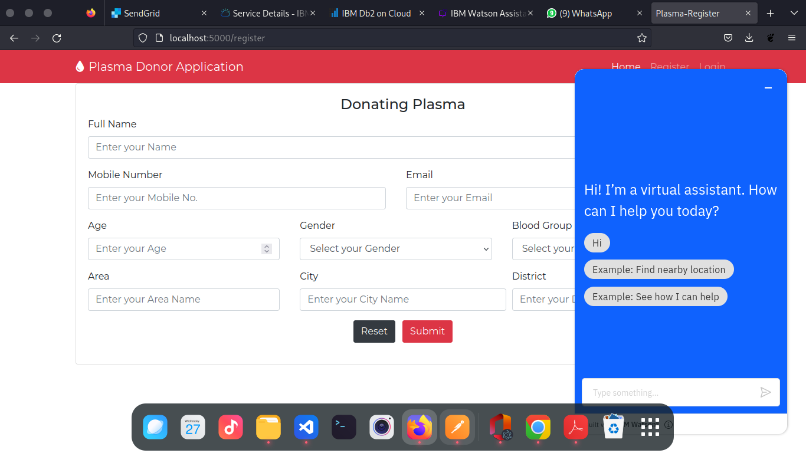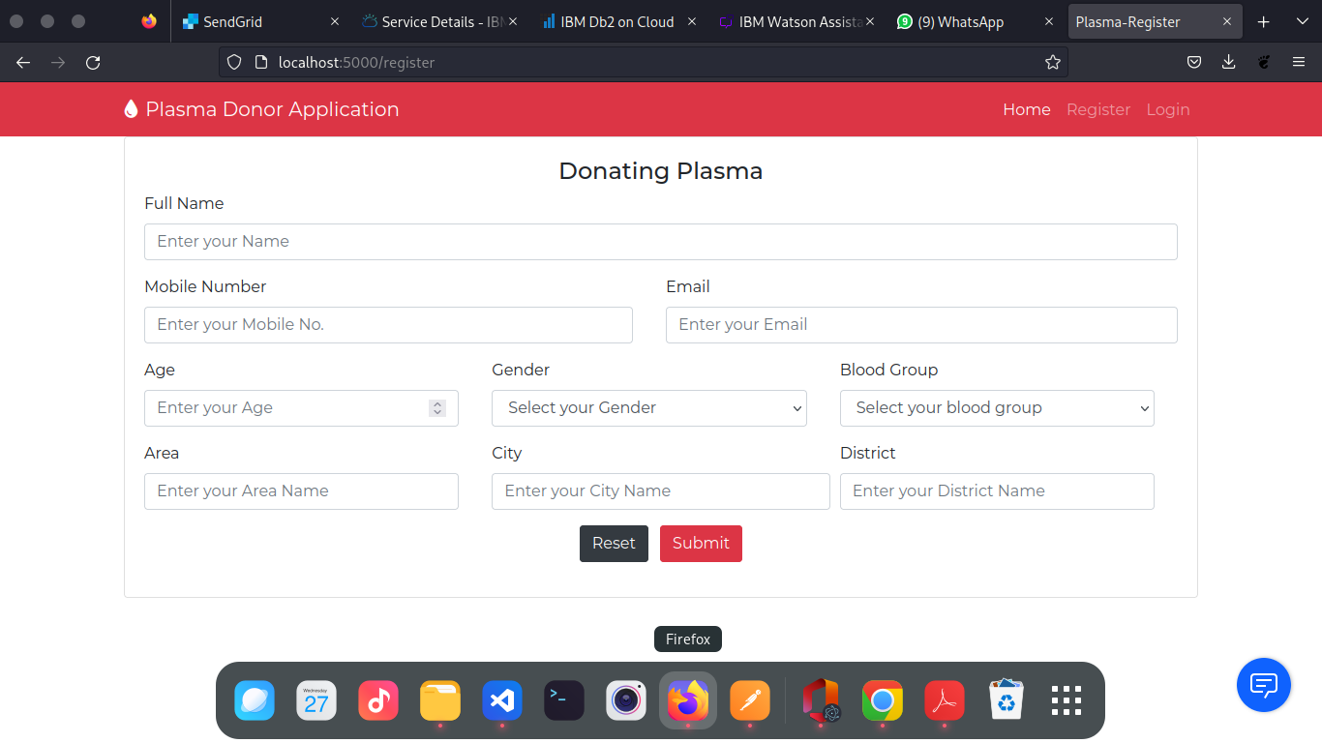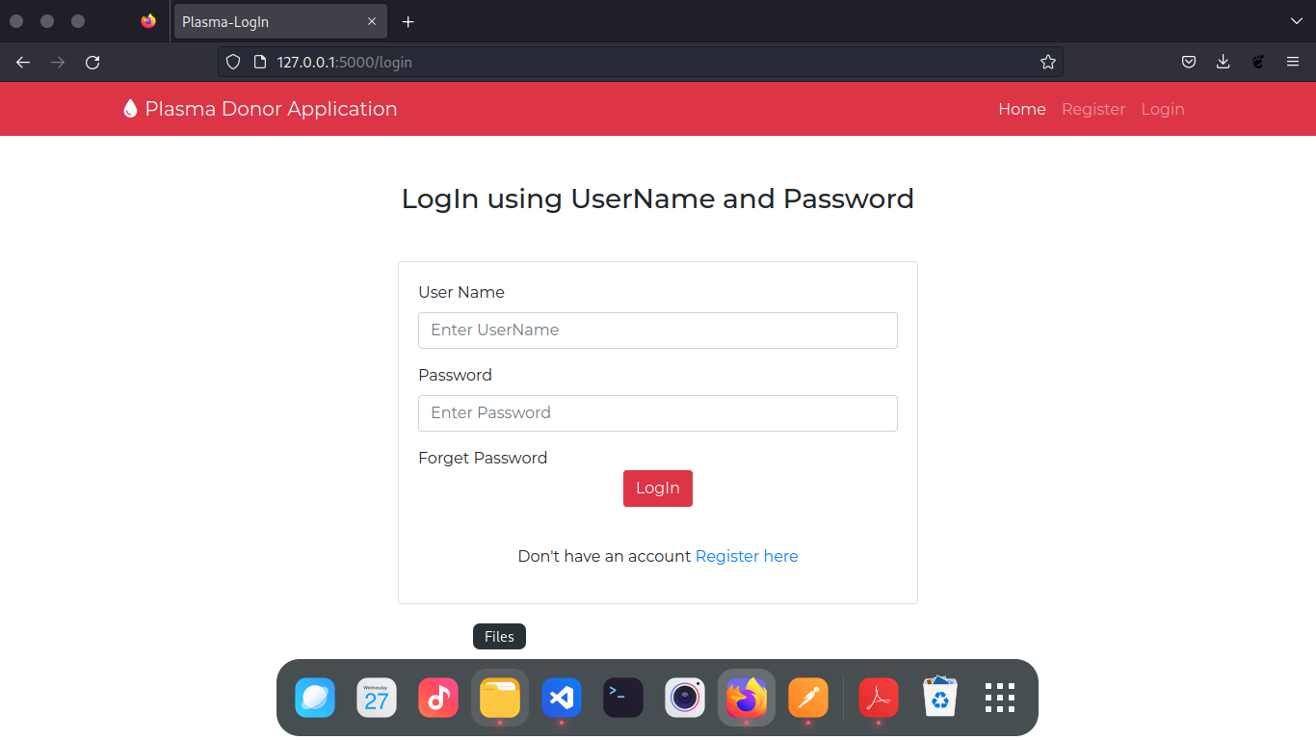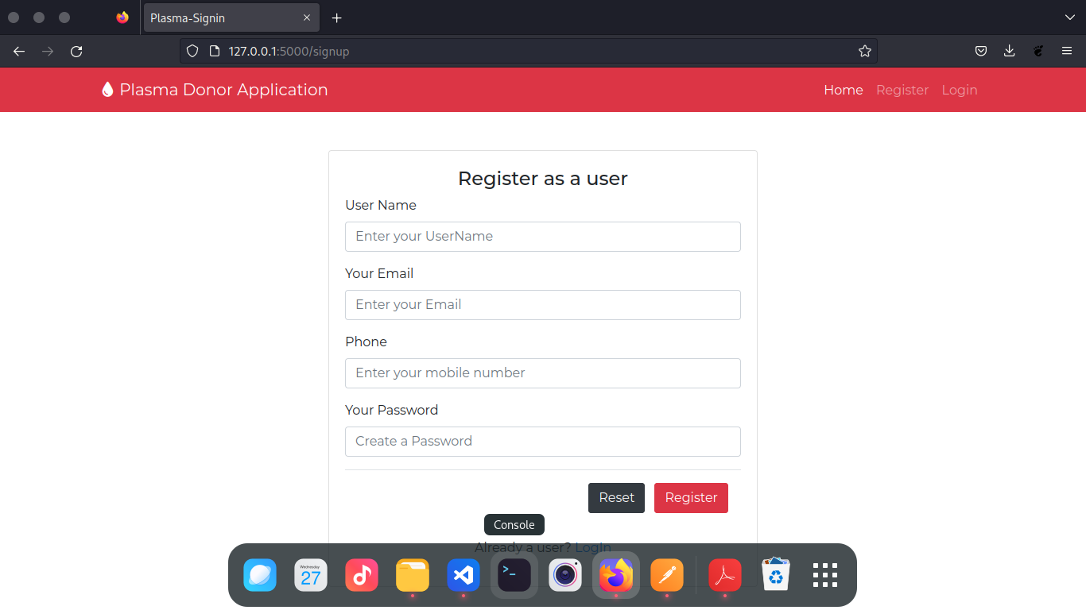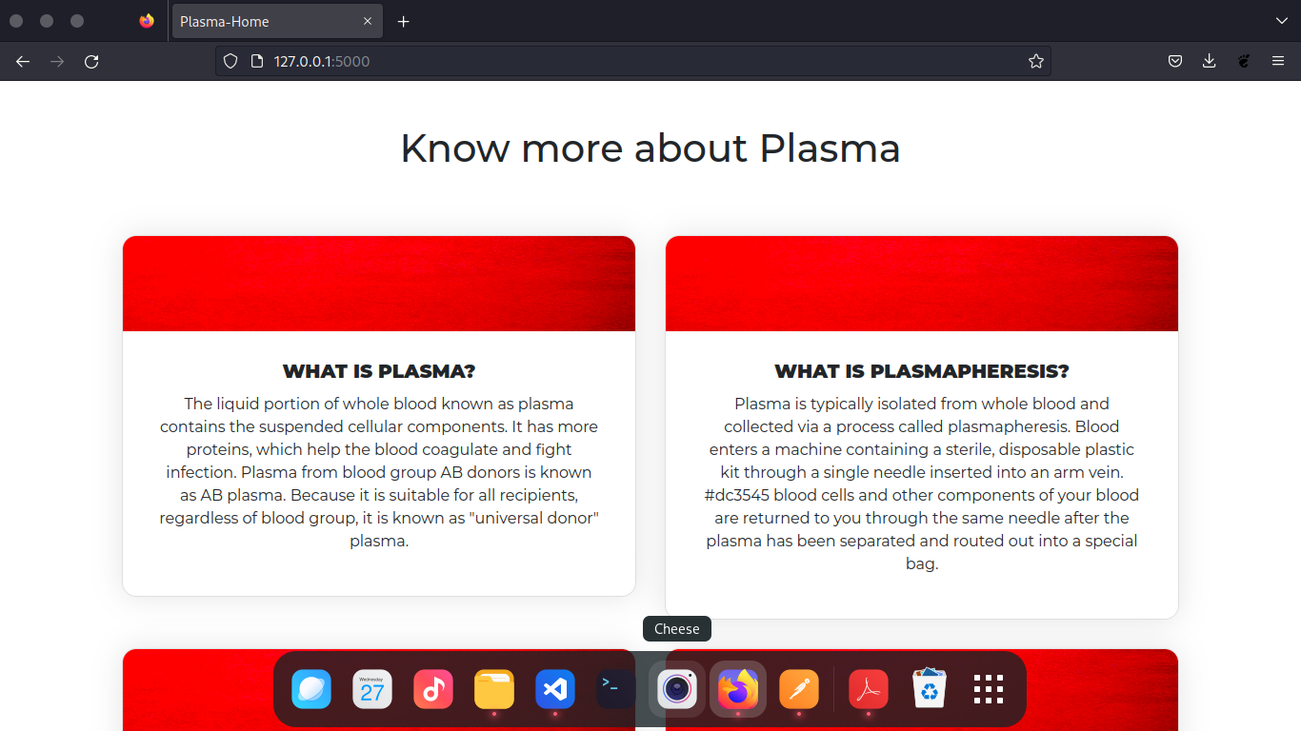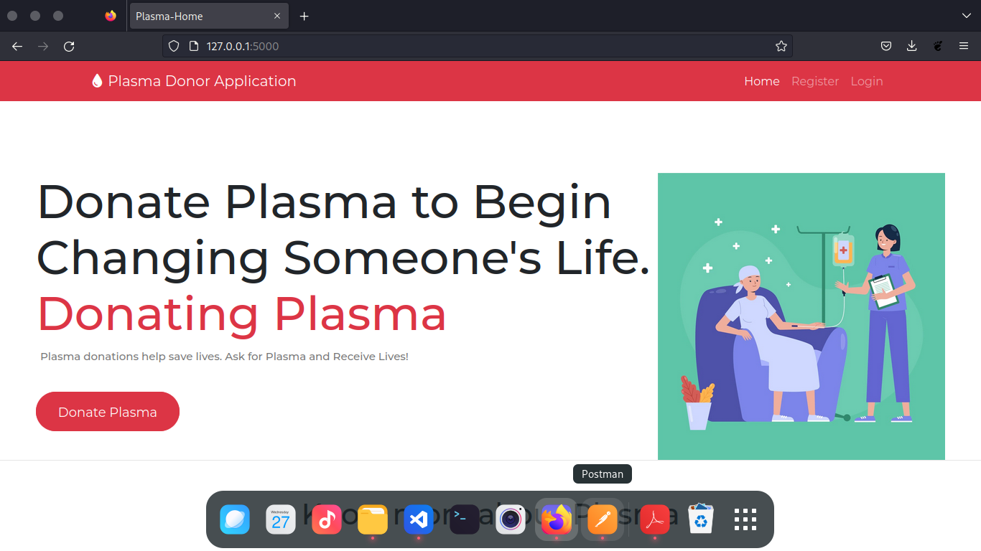

Donors can create an account by entering their email address. Once enrolled, The Donor can sign up by entering his or her password. The graphic depicts the login page for Plasma Donors, which includes the E-mail and Password fields. The Donor's profile, where he or she must input the necessary information. Donor can retain his account based on his availability after registering. The registration page, which is pictured, includes Full Name, Email Address, Last Donation Date, Password, Contact Details, Blood Group, Location, and all other details. Other users can see and view the details of the available donors.

**10.ADVANTAGES & DISADVANTAGES**

***Advantages***

* ***Speed***

This website is fast and offers great accuracy as compared to manual

registered keeping.

* ***Maintenance***

Less maintenance is required

* ***User Friendly***

It is very easy to use and understand. It is easily workable and accessible for everyone.

* ***Fast Results***

It would help you to provide plasma donors easily depending upon the availability of it.

***Disadvantages***

* ***Internet***

It would require an internet connection for the working of the website.

* ***Auto- Verification***

It cannot automatically verify the genuine users.

**11.CONCLUSION**

Although the government is conducting large-scale Covid immunisation efforts, the volume of vaccines produced is insufficient to vaccinate the whole population at this time. With the number of corona positive cases increasing by the day, preserving lives has become the top priority. According to WHO estimates, more than 3 million individuals have died as a result of the coronavirus. Aside from immunisation, there is another scientific approach for treating a covid infected individual and lowering the chance of mortality. This plasma treatment is an experimental strategy to treating and recovering corona-positive individuals. This plasma treatment is thought to be both safe and promising. This plasma therapy is considered to be safe & promising. A person who has recovered from Covid can donate his/her plasma to a person who is infected with the coronavirus.

This technique suggested here tries to connect donors and patients using an internet application. Users can use this application to make a request for plasma donation or a necessity. Both parties have the option to accept or reject the request. To donate plasma, the user must provide a Covid Negative report. If somebody need a Plasma Donor, this system is employed. Blood and plasma donation is a type of citizen's social duty in which a person can voluntarily donate blood/plasma using our app. This application was built with the idea of ensuring that donors contribute blood/plasma to the community. This approach is designed to be user-friendly so that anybody may access and manage his or her account. This application will disrupt the blood/plasma supply chain and assist the poor in finding free donors. This project will assist new blood and plasma banks in improving their services and transitioning from traditional to user-friendly frameworks.

**12.FUTURE SCOPE**

Plasma Application may be created to boost user accessibility even further by combining it with other social network application programme interfaces (APIs). As a result, users may log in and sign up using a variety of social networks. This increases the number of donors and improves the procedure of blood donation.

The user interface (UI) can be improved in the future to accommodate a global audience by supporting multiple languages from different countries. Data scraping from many social networks may be done and shown in the Blood/Plasma Request Feeds. Appointments can be synced with Google and Outlook calendars for user convenience.

The Donor and Beneficiary Stories feature aims to foster a sense of community. Donors will be able to view and share personal experiences related to their donation; recipients will be able to share their experiences of receiving blood transfusions that contributed to their improved health and lives.

When a user is in the process of donating, the Live Check-in Process feature aims to provide a better experience in terms of waiting time. We believe that providing a more efficient experience will encourage the user to look forwards to his blood/plasma donation appointments.

**13.APPENDIX**

* ***GitHub and Source code Link - <https://github.com/IBM-EPBL/IBM-Project-661-1658313474>***
* ***Demo video - <https://drive.google.com/file/d/1RwARsy8ug9O9fvFy9WcJelWYMDcabddq/view?usp=sharing>***